Silicon Nitride Integrated Photonic CNOT Gate For Linear Optical Quantum Computing
By Morgan McCabe

Abstract
This report presents the design of a proof-of-concept silicon nitride 4×4 unitary photonic CNOT gate at 780nm for linear optical quantum computing. The device includes grating couplers, MMIs, a thermo-optically tuned MZI, and an AMZI modeled using Interconnect. Coupling efficiency results from each individual component provide strong basis for future fabrication.

Introduction
Linear optical quantum computing uses interference, coupling, and phase control to realise quantum logic in integrated photonic circuits. This report presents a proof-of-concept silicon nitride 4×4 unitary CNOT architecture at 780 nm, designed within CORNERSTONE constraints and evaluated through simulation of grating couplers, MMIs, thermo-optic MZIs, and AMZI components.

Design Concept
The device is a proof-of-concept SiN 4×4 unitary photonic circuit for a linear optical CNOT gate at 780 nm, comprising grating couplers, 50:50 and 33:66 MMIs, an MZI, and an AMZI, with single-mode operation targeted in the fundamental TE mode. Together, these components form the complete photonic circuit required to realize the target linear optical CNOT operation.

Design Rationale
The foundry assigned for this project was CORNERSTONE UK, based in Southampton [2]. Consequently, the design decisions were constrained by both the fabrication capabilities of the foundry and the technical requirements needed to realize the intended device.
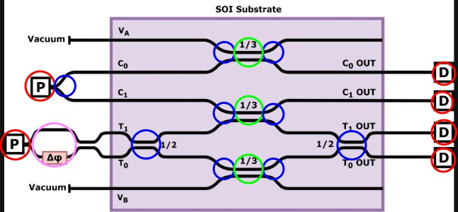
Fig. 4.1. 4x4 Unitary

‘
A Grating couplers: fibre–chip input/output coupling.

B 50:50 MMI couplers: equal power splitting/recombination for interference.
C 33:66 MMI couplers: unequal splitting for the required transformation probabilities.
D MZIs: phase control between optical paths.
E AMZIs: asymmetric path-length difference for additional phase control.

4.1.) General Values

4.1.1.) Wavelength
A wavelength of 780 nm was chosen for its relevance to visible-range quantum photonics, particularly rubidium-based quantum-memory systems [3]. It also allows investigation of a less mature integrated-photonics design space than the standard 1550 nm telecommunications regime [4].

4.1.2.) Material
The waveguide core material was chosen as Si3N4 due to its suitability for operation at 780 nm and its availability within the CORNERSTONE visible photonics platform [5; 6]. The top and bottom cladding layers were chosen as SiO2, consistent with standard silica-based integrated photonic structures [7]. Together, these materials provide sufficient refractive-index contrast to confine the optical mode within the core. ∆n_{eff} ≈ 0.209

4.1.3.) Waveguide dimensions and guided modes
The waveguide height was set to 0.3 µm, consistent with the CORNERSTONE SiN platform specification [8]. The width was set to 0.35 µm to support single-mode operation at 780 nm, as verified by the FDE mode analysis (Figs. 3.1–3.6).
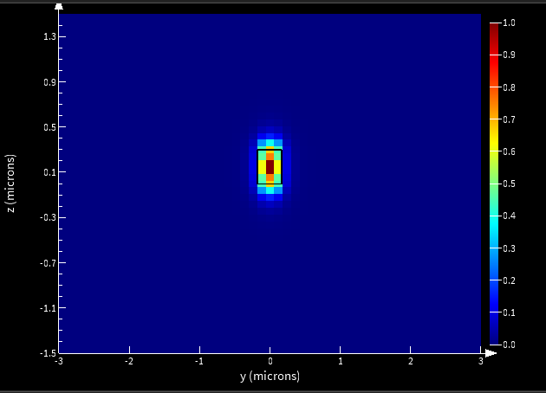
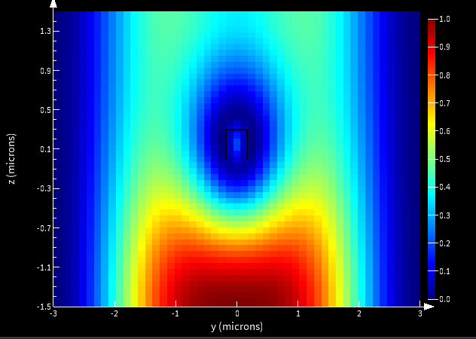
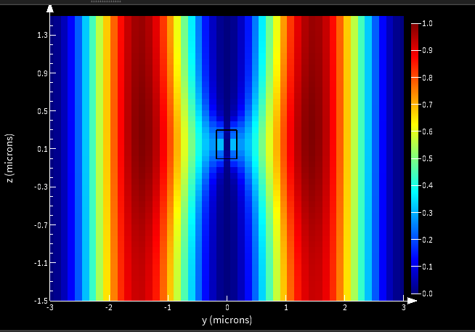
Fig. 4.2. 0.35 µm, TE Mode 1 Fig. 4.3. 0.35 µm, TE Mode 2 Fig. 4.4. 0.35 µm, TE Mode 3
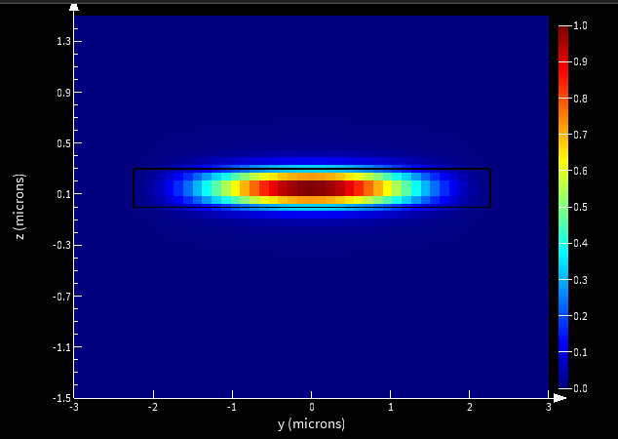
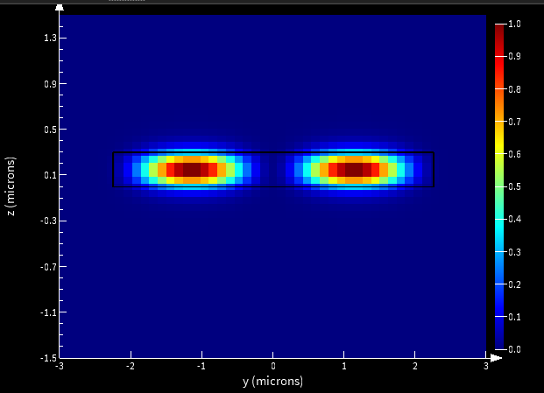
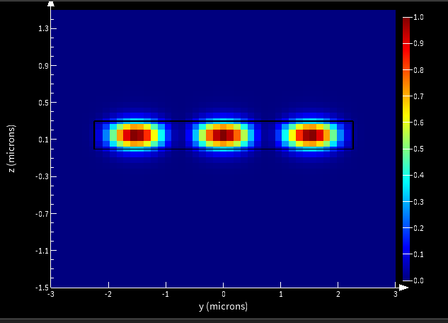

Fig. 4.5. 4.5 µm, TE Mode 1 Fig. 4.6. 4.5 µm, TE Mode 2 Fig. 4.7. 4.5 µm, TE Mode 3

4.2.) Grating Couplers
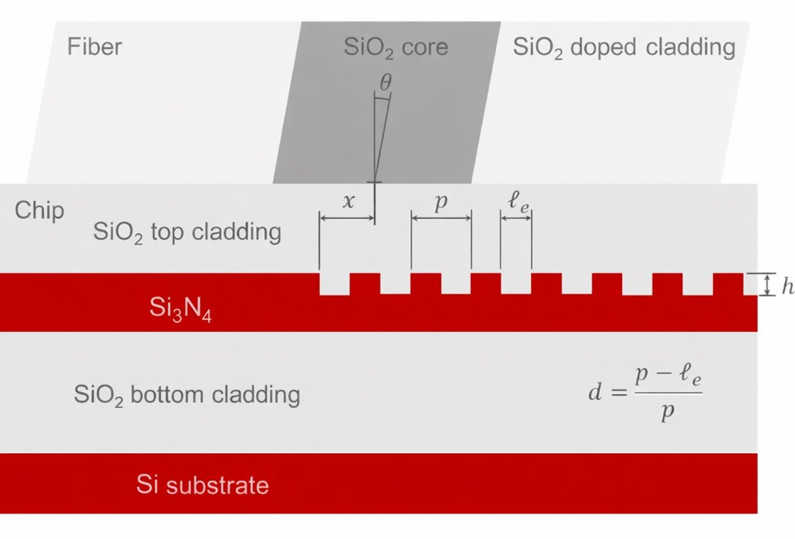
Fig. 4.8. Grating Coupler

4.2.1.) Initial parameters
Initial design parameters were chosen from physical estimates and literature values.

4.2.2.) Set by literature sources
- Fibre angle = 10◦ [9; 10]
- Core / cladding diameter = 4.9 µm / 125 µm [13, p. 4, Table 4]
- Core / cladding refractive index = 1.44427 / 1.43482 [14]

4.2.3.) Set by Estimation

where:
- m = diffraction order (= 1)
- λ = wavelength being coupled (0.78 µm)
mλ
n_{eff} − n_{clad} sin θ
Λ =

- n_{eff} = effective index of the optical mode (1.649) Calculated using Lumerical MODE [See fig 4.1]
- n_{clad} = effective index of the cladding (1.44)[14]
- θ = fibre angle to the grating normal (10◦)[9], [10]

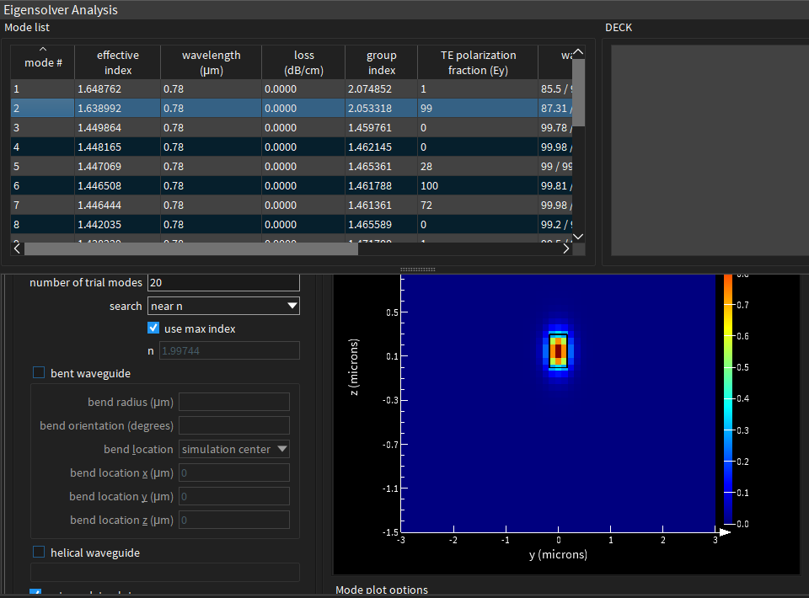

Fig. 4.9. Lumerical FDE

Substituting these values in the grating phase matching equation gives an initial pitch of:
Λ = 0.558 µm
  - Etch depth: initial value 0.15 µm, from a maximum waveguide height of 0.3 µm.
  - Duty cycle: initially set to 0.5.
  - Grating length: at least 9 µm to accommodate the fibre core; with a 10◦ fibre tilt,
9
Lmin ≈ cos 10◦ ≈ 9.14 µm.

4.3.) MMIs
MMIs were selected instead of directional couplers because they offer greater fabrication tolerance and lower sensitivity to dimensional variation [11; 12]. Both 50:50 and 33:66 power splitting were required, so the geometries were optimised for stable splitting ratio and transmission. The main optimisable parameters were:
  - MMI core length / width
  - input / output taper length / mouth
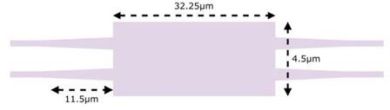

Fig. 4.10. MMI Geometry

the way to measure the components performance is splitting ration and transmissions efficiency.

4.4.) MZIs and AMZI
MZIs were used to provide controllable phase shifts within the 4×4 unitary circuit, with thermo-optic tuning chosen for platform compatibility and practical on-chip modulation. AMZIs were used where asymmetric interference was required, particularly for the 1/3 splitting condition.

Component Simulation process and Analysis
For grating couplers, FDTD was chosen because it models the full electromagnetic behaviour of the structure, including diffraction, reflection, radiation loss, and fibre-to-waveguide coupling.

5.1.) FOM
Grating-coupler efficiency was measured using the Figure of Merit (FOM), calculated in Lumerical with the script shown in Fig. 5.1.
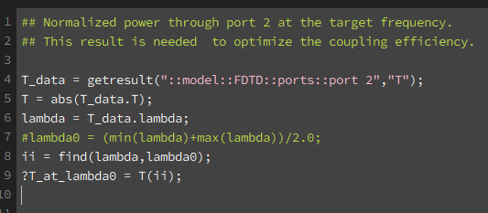

Fig. 5.1. FOM Script

5.2.) 2D Simulation
Although frequency-domain monitors were not used to directly measure coupling efficiency, they were useful for visualizing the spatial distribution of optical coupling (Fig. 5.2). A refractive-index monitor was also used to confirm the index contrast affecting the guided-mode effective index, n_{eff} (Fig. 5.3).

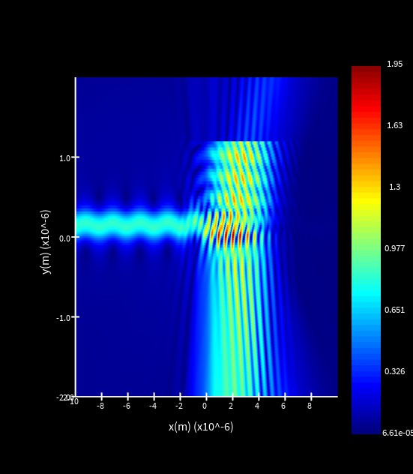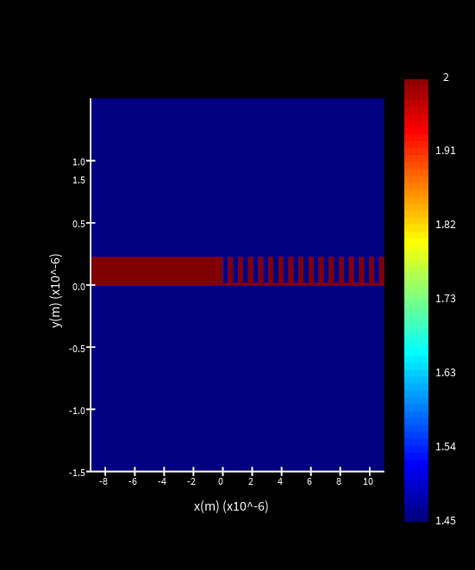

Fig. 5.2. Field-Monitor

Fig. 5.3. Index-Monitor 1

A distinction was required between parameters varied in 2D and 3D simulations; for example, changing grating width had no effect in 2D due to the limitations of the model (Fig. 5.4).
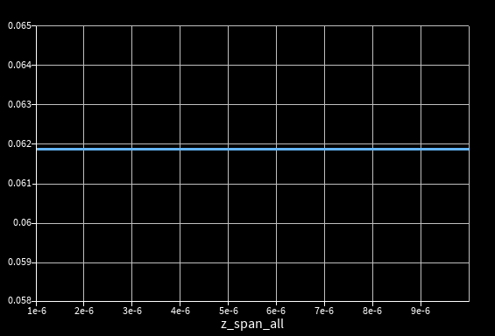
Fig. 5.4. Width Sweep

Table 1. Parameters altered in 2D and 3D simulations

Parameters altered in 2D | Parameters altered in 3D
Pitch | Pitch
Duty cycle | Duty cycle
Etch depth | Etch depth
Fibre angle | Fibre angle
Fibre x-position on grating | Fibre x-position on grating
– | Grating width
– | Grating length

2D parameter sweeps were first performed to identify the approximate optimum region. Figures 5.3–5.6 show the initial pitch and duty cycle sweeps, followed by the re-swept duty cycle and pitch after updating parameter values.

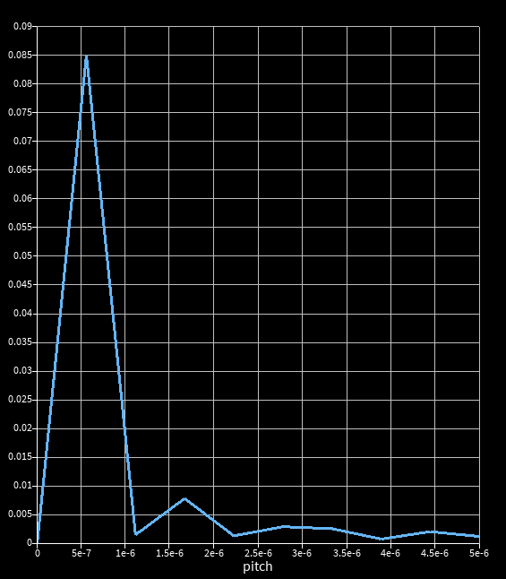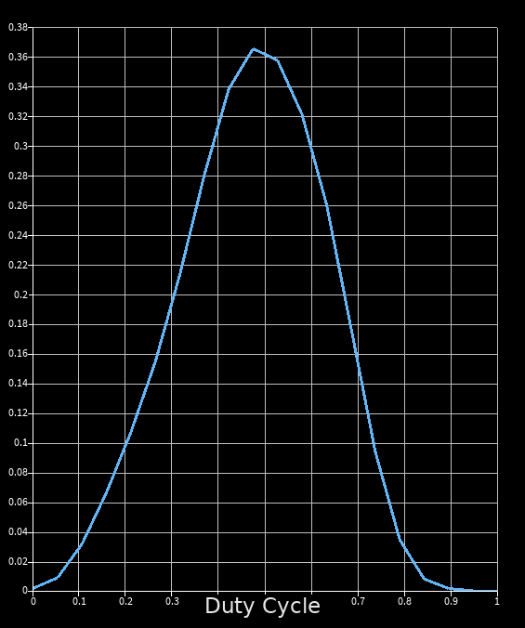

Fig. 5.5. Pitch-Sweep 1

Fig. 5.6. Duty-cycle Sweep 1

The sweeps showed clear parameter interdependence. After updating the pitch, the optimum duty cycle shifted (Figs. 5.6 and 5.7), and re-sweeping the pitch after changing duty cycle showed a further shift in its optimum. This justified the iterative optimization process.
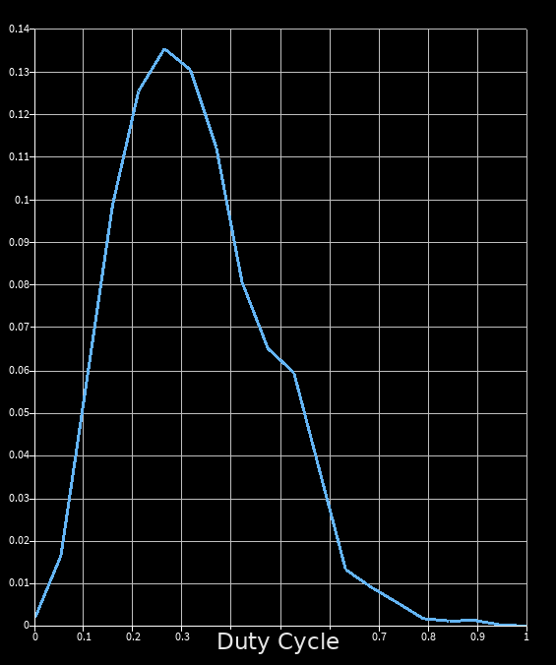
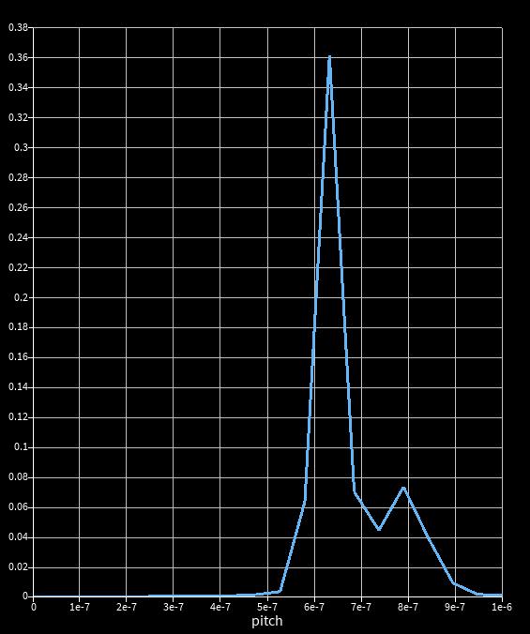
Fig. 5.7. Pitch-Sweep 2 Fig. 5.8. Duty-cycle Sweep 2

This was a crucial factor when developing the full optimization process

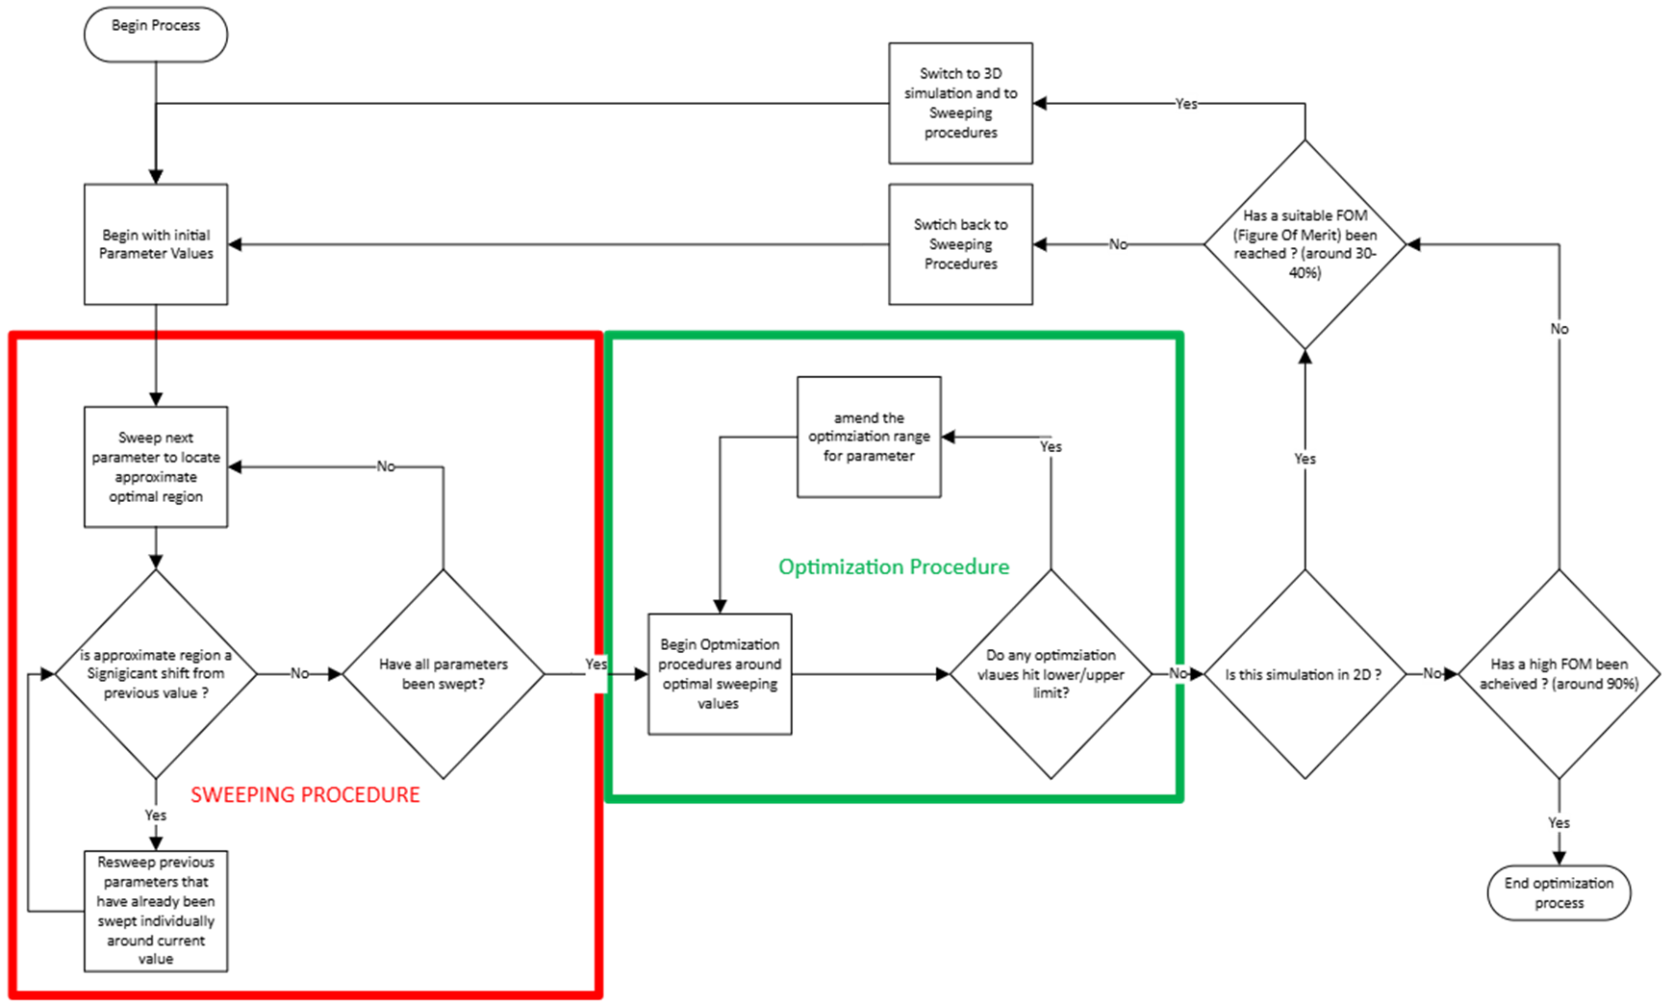
Fig. 5.9. Design-Flow

Table 2. 2D Rectangle Simulation Results

Iteration Number | Pitch (µm) | Etch Depth (µm) | Duty Cycle | Grating  Length (µm) | Grating  Width (µm) | Fibre Core  Position (µm) | Fibre  Angle (◦) | Core  Diameter (µm) | Core Index | Cladding  Diameter (µm) | Cladding Index | Grating Shape | FOM (%) | Changed Parameter
1 | 0.558 | 0.15 | 0.5 | 12 | 6 | 6 | 10 | 4.9 | 1.44427 | 125 | 1.43482 | Rectangular | 7.28213 | Initial
2 | 0.58 | 0.15 | 0.5 | 12 | 6 | 6 | 10 | 4.9 | 1.44427 | 125 | 1.43482 | Rectangular | 8.91 | Pitch
3 | 0.58 | 0.16 | 0.5 | 12 | 6 | 6 | 10 | 4.9 | 1.44427 | 125 | 1.43482 | Rectangular | 8.43 | Etch Depth
4 | 0.58 | 0.16 | 0.495 | 12 | 6 | 6 | 10 | 4.9 | 1.44427 | 125 | 1.43482 | Rectangular | 9.74 | Duty Cycle
5 | 0.58 | 0.16 | 0.495 | 12 | 6 | 6.2 | 10 | 4.9 | 1.44427 | 125 | 1.43482 | Rectangular | 10.52 | Fibre Core Position
6 | 0.58 | 0.16 | 0.495 | 12 | 6 | 6.2 | 11.2 | 4.9 | 1.44427 | 125 | 1.43482 | Rectangular | 10.08 | Fibre Angle
7 | 0.595 | 0.16 | 0.495 | 12 | 6 | 6.2 | 11.2 | 4.9 | 1.44427 | 125 | 1.43482 | Rectangular | 11.86 | Pitch
8 | 0.6 | 0.175 | 0.49 | 12 | 6 | 6.1 | 12 | 4.9 | 1.44427 | 125 | 1.43482 | Rectangular | 13.42 | Optimization (all)
9 | 0.61 | 0.175 | 0.49 | 12 | 6 | 6.1 | 12 | 4.9 | 1.44427 | 125 | 1.43482 | Rectangular | 14.65 | Pitch
10 | 0.61 | 0.185 | 0.49 | 12 | 6 | 6.1 | 12 | 4.9 | 1.44427 | 125 | 1.43482 | Rectangular | 14.18 | Etch Depth
11 | 0.61 | 0.185 | 0.486 | 12 | 6 | 6.1 | 12 | 4.9 | 1.44427 | 125 | 1.43482 | Rectangular | 15.42 | Duty Cycle
12 | 0.61 | 0.185 | 0.486 | 12 | 6 | 5.95 | 12 | 4.9 | 1.44427 | 125 | 1.43482 | Rectangular | 16.11 | Fibre Core Position
13 | 0.61 | 0.185 | 0.486 | 12 | 6 | 5.95 | 13.5 | 4.9 | 1.44427 | 125 | 1.43482 | Rectangular | 15.73 | Fibre Angle
14 | 0.621 | 0.185 | 0.486 | 12 | 6 | 5.95 | 13.5 | 4.9 | 1.44427 | 125 | 1.43482 | Rectangular | 17.26 | Pitch
15 | 0.621 | 0.198 | 0.486 | 12 | 6 | 5.95 | 13.5 | 4.9 | 1.44427 | 125 | 1.43482 | Rectangular | 16.88 | Etch Depth
16 | 0.6235 | 0.2005 | 0.484114 | 12 | 6 | 5.9 | 14.8 | 4.9 | 1.44427 | 125 | 1.43482 | Rectangular | 19.24 | Optimization (all)
17 | 0.628 | 0.2005 | 0.484114 | 12 | 6 | 5.9 | 14.8 | 4.9 | 1.44427 | 125 | 1.43482 | Rectangular | 20.31 | Pitch
18 | 0.628 | 0.202 | 0.484114 | 12 | 6 | 5.9 | 14.8 | 4.9 | 1.44427 | 125 | 1.43482 | Rectangular | 19.96 | Etch Depth
19 | 0.628 | 0.202 | 0.4825 | 12 | 6 | 5.9 | 14.8 | 4.9 | 1.44427 | 125 | 1.43482 | Rectangular | 21.08 | Duty Cycle
20 | 0.628 | 0.202 | 0.4825 | 12 | 6 | 5.85 | 14.8 | 4.9 | 1.44427 | 125 | 1.43482 | Rectangular | 21.76 | Fibre Core Position
21 | 0.628 | 0.202 | 0.4825 | 12 | 6 | 5.85 | 16 | 4.9 | 1.44427 | 125 | 1.43482 | Rectangular | 21.33 | Fibre Angle
22 | 0.631579 | 0.202 | 0.4825 | 12 | 6 | 5.85 | 16 | 4.9 | 1.44427 | 125 | 1.43482 | Rectangular | 23.04 | Pitch
23 | 0.631579 | 0.205203 | 0.4825 | 12 | 6 | 5.85 | 16 | 4.9 | 1.44427 | 125 | 1.43482 | Rectangular | 31.67 | Etch Depth
24 | 0.631579 | 0.205203 | 0.4832 | 12 | 6 | 5.8 | 17.2 | 4.9 | 1.44427 | 125 | 1.43482 | Rectangular | 32.88 | Optimization (all)
25 | 0.631579 | 0.205203 | 0.484114 | 12 | 6 | 5.8 | 17.2 | 4.9 | 1.44427 | 125 | 1.43482 | Rectangular | 30.42 | Duty Cycle
26 | 0.631579 | 0.205203 | 0.484114 | 12 | 6 | 5.8 | 17.8947 | 4.9 | 1.44427 | 125 | 1.43482 | Rectangular | 29.87 | Fibre Angle
27 | 0.601389 | 0.213067 | 0.495117 | 12 | 6 | 5.78 | 15.4248 | 4.9 | 1.44427 | 125 | 1.43482 | Rectangular | 35.0043 | Optimization (all)

After iterative sweeps and optimization, a suitable parameter set was selected for 3D simulation, since 2D no longer captured all relevant effects.(Fig. 5.10) proves increase coupling.
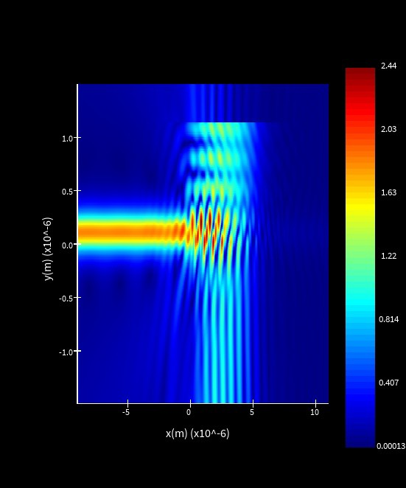
Fig. 5.10. 2D-Field Monitor

5.3.) 3D Simulation
Immediately, the optimal 2D results provided extremely poor efficiency. The other factors that have not been optimized.
Table 3. Inital 3D simulation

Pitch (µm) | Etch Depth (µm) | Duty Cycle | Grating Length  (µm) | Grating Width  (µm) | Fibre Core Position  (µm) | Fibre Angle  (◦) | Core Diameter  (µm) | Core Index | Cladding Diameter  (µm) | Cladding Index | Grating Shape | FOM (%)
0.601389 | 0.213067 | 0.495117 | 12 | 6 | 5.78 | 15.4248 | 4.9 | 1.44427 | 125 | 1.43482 | Rectangular | 0.0000109749

5.3.1.) Coupling in Fibre
To model coupling from a tilted fibre in 3D, the port orientation and rotation offset were calculated from the fibre angle. First, the fibre angle was converted from degrees to radians:
θfiber rad = θfiber ( π J [1]
, 180
The port angle was then defined as

θport = −θfiber [2]
so that the injected field propagated along the tilted fibre axis. A rotation offset was also introduced to account for the lateral displacement caused by the fibre inclination [15]:
∆x = 4D_{core} tan (θ_{fiber,rad}) [3]
where ∆x is the port rotation offset and Dcore is the fibre core diameter. This correction improved alignment between the excitation port and the tilted fibre, helping to produce a more accurate representation of fibre-to-grating coupling in the 3D simulation. Fig (5.11) verifies good coupling
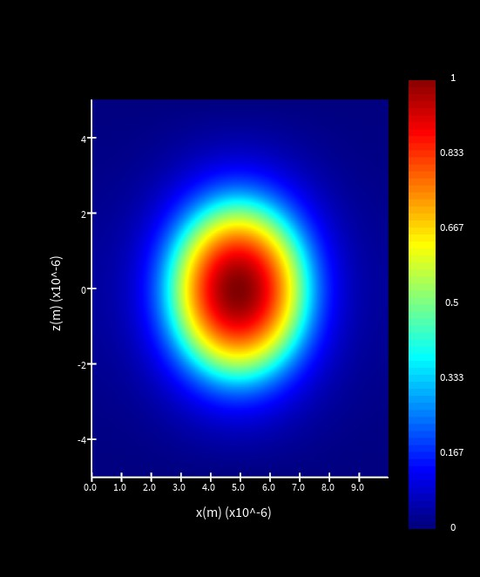
Fig. 5.11. Fibre Mode

5.3.2.) Grating Width limitation
Grating width had limited influence once it was large enough to overlap the fibre core, so further optimisation was unnecessary (fig 5.12).
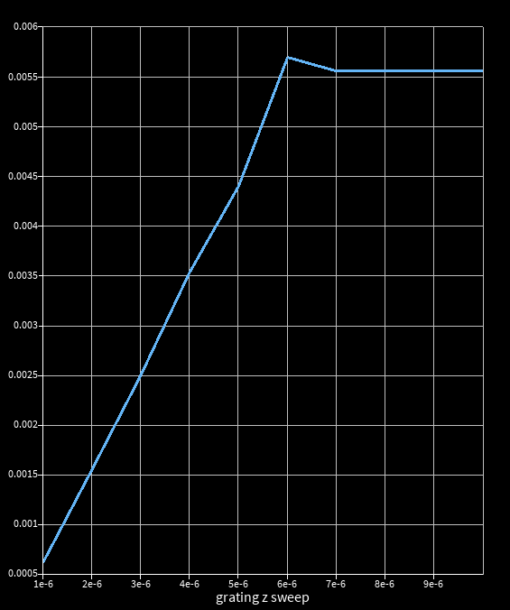

Fig. 5.12. Width-Sweep1

5.3.3.) 3D Results
Table 3 outlines the de-satisfying values, providing the hint that more drastic changes were required
Table 4. 3D Rectangle Simulation Results

3D Iteration  Number | Pitch  (µm) | Etch Depth  (µm) | Duty Cycle  (0–1) | Grating Length  (µm) | Grating Width  (µm) | Fibre Core Position  (µm from waveguide) | Fibre Angle  (◦) | Core Diameter  (µm) | Core Refractive  Index | Cladding Diameter  (µm) | Cladding Refractive  Index | Grating  Shape | FOM  (%) | Changed  Parameter
1 | 0.601389 | 0.213067 | 0.495117 | 12 | 6 | 6 | 15.4248 | 4.9 | 1.44427 | 125 | 1.43482 | Rectangle | 1.09749E-05 | Initial
2 | 0.59 | 0.213067 | 0.495117 | 12 | 6 | 6 | 15.4248 | 4.9 | 1.44427 | 125 | 1.43482 | Rectangle | 0.00012 | Pitch
3 | 0.59 | 0.205 | 0.495117 | 12 | 6 | 6 | 15.4248 | 4.9 | 1.44427 | 125 | 1.43482 | Rectangle | 0.0001 | Etch Depth
4 | 0.59 | 0.205 | 0.492 | 12 | 6 | 6 | 15.4248 | 4.9 | 1.44427 | 125 | 1.43482 | Rectangle | 0.00019 | Duty Cycle
5 | 0.59 | 0.205 | 0.492 | 11.7 | 6 | 6 | 15.4248 | 4.9 | 1.44427 | 125 | 1.43482 | Rectangle | 0.00023 | Grating Length
6 | 0.59 | 0.205 | 0.492 | 11.7 | 6 | 5.2 | 15.4248 | 4.9 | 1.44427 | 125 | 1.43482 | Rectangle | 0.00021 | Fibre Core Position
7 | 0.59 | 0.205 | 0.492 | 11.7 | 6 | 5.2 | 14.2 | 4.9 | 1.44427 | 125 | 1.43482 | Rectangle | 0.00031 | Fibre Angle
8 | 0.582 | 0.198 | 0.4895 | 11.2 | 6 | 4.6 | 13.2 | 4.9 | 1.44427 | 125 | 1.43482 | Rectangle | 0.00048 | Optimizing
9 | 0.575 | 0.198 | 0.4895 | 11.2 | 6 | 4.6 | 13.2 | 4.9 | 1.44427 | 125 | 1.43482 | Rectangle | 0.00044 | Pitch
10 | 0.575 | 0.19 | 0.4895 | 11.2 | 6 | 4.6 | 13.2 | 4.9 | 1.44427 | 125 | 1.43482 | Rectangle | 0.00059 | Etch Depth
11 | 0.575 | 0.19 | 0.4865 | 11.2 | 6 | 4.6 | 13.2 | 4.9 | 1.44427 | 125 | 1.43482 | Rectangle | 0.00073 | Duty Cycle
12 | 0.575 | 0.19 | 0.4865 | 10.7 | 6 | 4.6 | 13.2 | 4.9 | 1.44427 | 125 | 1.43482 | Rectangle | 0.00067 | Grating Length
13 | 0.575 | 0.19 | 0.4865 | 10.7 | 6 | 3.8 | 13.2 | 4.9 | 1.44427 | 125 | 1.43482 | Rectangle | 0.00086 | Fibre Core Position
14 | 0.575 | 0.19 | 0.4865 | 10.7 | 6 | 3.8 | 12.1 | 4.9 | 1.44427 | 125 | 1.43482 | Rectangle | 0.00081 | Fibre Angle
15 | 0.575 | 0.19 | 0.4865 | 10.1 | 6 | 3.8 | 12.1 | 4.9 | 1.44427 | 125 | 1.43482 | Rectangle | 0.00102 | Grating Length
16 | 0.565 | 0.18 | 0.484 | 9.5 | 6 | 2.7 | 11 | 4.9 | 1.44427 | 125 | 1.43482 | Rectangle | 0.00129 | Optimizing
17 | 0.558 | 0.18 | 0.484 | 9.5 | 6 | 2.7 | 11 | 4.9 | 1.44427 | 125 | 1.43482 | Rectangle | 0.00118 | Pitch
18 | 0.558 | 0.17 | 0.484 | 9.5 | 6 | 2.7 | 11 | 4.9 | 1.44427 | 125 | 1.43482 | Rectangle | 0.00147 | Etch Depth
19 | 0.558 | 0.17 | 0.4815 | 9.5 | 6 | 2.7 | 11 | 4.9 | 1.44427 | 125 | 1.43482 | Rectangle | 0.00166 | Duty Cycle
20 | 0.558 | 0.17 | 0.4815 | 9 | 6 | 2.7 | 11 | 4.9 | 1.44427 | 125 | 1.43482 | Rectangle | 0.00155 | Grating Length
21 | 0.558 | 0.17 | 0.4815 | 9 | 6 | 1.2 | 11 | 4.9 | 1.44427 | 125 | 1.43482 | Rectangle | 0.00198 | Fibre Core Position
22 | 0.558 | 0.17 | 0.4815 | 9 | 6 | 1.2 | 10 | 4.9 | 1.44427 | 125 | 1.43482 | Rectangle | 0.00186 | Fibre Angle
23 | 0.558 | 0.17 | 0.4815 | 8.6 | 6 | 1.2 | 10 | 4.9 | 1.44427 | 125 | 1.43482 | Rectangle | 0.00212 | Grating Length
24 | 0.548 | 0.16 | 0.479 | 8.1 | 6 | 0.15 | 9.2 | 4.9 | 1.44427 | 125 | 1.43482 | Rectangle | 0.00241 | Optimizing
25 | 0.54 | 0.16 | 0.479 | 8.1 | 6 | 0.15 | 9.2 | 4.9 | 1.44427 | 125 | 1.43482 | Rectangle | 0.00229 | Pitch
26 | 0.54 | 0.15 | 0.479 | 8.1 | 6 | 0.15 | 9.2 | 4.9 | 1.44427 | 125 | 1.43482 | Rectangle | 0.00253 | Etch Depth
27 | 0.54 | 0.15 | 0.4765 | 8.1 | 6 | 0.15 | 9.2 | 4.9 | 1.44427 | 125 | 1.43482 | Rectangle | 0.00272 | Duty Cycle
28 | 0.54 | 0.15 | 0.4765 | 7.9 | 6 | 0.15 | 9.2 | 4.9 | 1.44427 | 125 | 1.43482 | Rectangle | 0.00261 | Grating Length
29 | 0.54 | 0.15 | 0.4765 | 7.9 | 6 | 0.01 | 9.2 | 4.9 | 1.44427 | 125 | 1.43482 | Rectangle | 0.00298 | Fibre Core Position
30 | 0.54 | 0.15 | 0.4765 | 7.9 | 6 | 0.01 | 8.95 | 4.9 | 1.44427 | 125 | 1.43482 | Rectangle | 0.00285 | Fibre Angle
31 | 0.54 | 0.15 | 0.4765 | 7.6 | 6 | 0.01 | 8.95 | 4.9 | 1.44427 | 125 | 1.43482 | Rectangle | 0.00311 | Grating Length
32 | 0.528 | 0.135 | 0.474 | 7.4 | 6 | 0.00001 | 8.7 | 4.9 | 1.44427 | 125 | 1.43482 | Rectangle | 0.00356 | Optimizing
33 | 0.522 | 0.135 | 0.474 | 7.4 | 6 | 0.00001 | 8.7 | 4.9 | 1.44427 | 125 | 1.43482 | Rectangle | 0.00338 | Pitch
34 | 0.522 | 0.128 | 0.474 | 7.4 | 6 | 0.00001 | 8.7 | 4.9 | 1.44427 | 125 | 1.43482 | Rectangle | 0.00385 | Etch Depth
35 | 0.522 | 0.128 | 0.4728 | 7.4 | 6 | 0.00001 | 8.7 | 4.9 | 1.44427 | 125 | 1.43482 | Rectangle | 0.00422 | Duty Cycle
36 | 0.522 | 0.128 | 0.4728 | 7.3 | 6 | 4.03024E-06 | 8.20049 | 4.9 | 1.44427 | 125 | 1.43482 | Rectangle | 0.00274478 | Grating Length
37 | 0.522 | 0.128 | 0.4728 | 7.2 | 6 | 4.54622E-06 | 7.41282 | 4.9 | 1.44427 | 125 | 1.43482 | Rectangle | 0.002 | Fibre Core Position
38 | 0.522 | 0.128 | 0.4728 | 7.1 | 6 | 4.04045E-06 | 8.5 | 4.9 | 1.44427 | 125 | 1.43482 | Rectangle | 0.00254392 | Fibre Angle
39 | 0.522 | 0.128 | 0.4728 | 7 | 6 | 3.1592E-06 | 5 | 4.9 | 1.44427 | 125 | 1.43482 | Rectangle | 0.016623 | Grating Length
40 | 0.511408 | 0.119062 | 0.4712 | 6.9 | 6 | 4.18654E-06 | 8.95381 | 4.9 | 1.44427 | 125 | 1.43482 | Rectangle | 0.0181321 | Optimizing

Geometry Amendment
The rectangular geometry was not supported by any literature sources, instead a more curved / coned shape was common with efficient GC [16], [17]. All data since now has been from GC-V1 in Fig 6.2
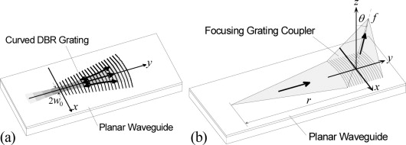
Fig. 6.1. Coned-GC [18]



Fig. 6.2. GC-V1

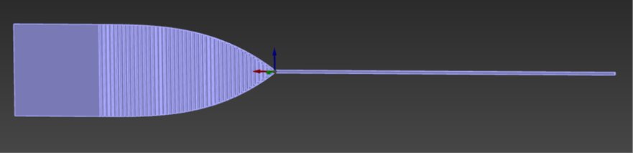

Fig. 6.3. GC-V2

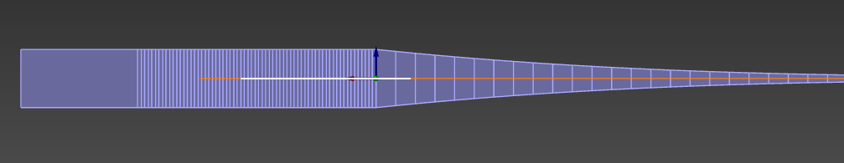

Fig. 6.4. GC-V3

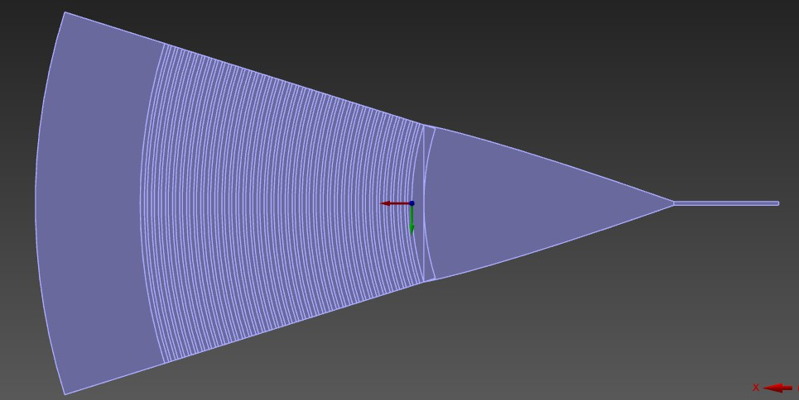

Fig. 6.5. GC-V4

As discussed in Section 5.2, increasing grating width alone did not improve performance. GC-V2 (Fig. 6.3) performed significantly worse, with increased scattering causing severe coupling loss (Fig. 6.6), likely due to poorer matching to the narrow TE waveguide mode.
•
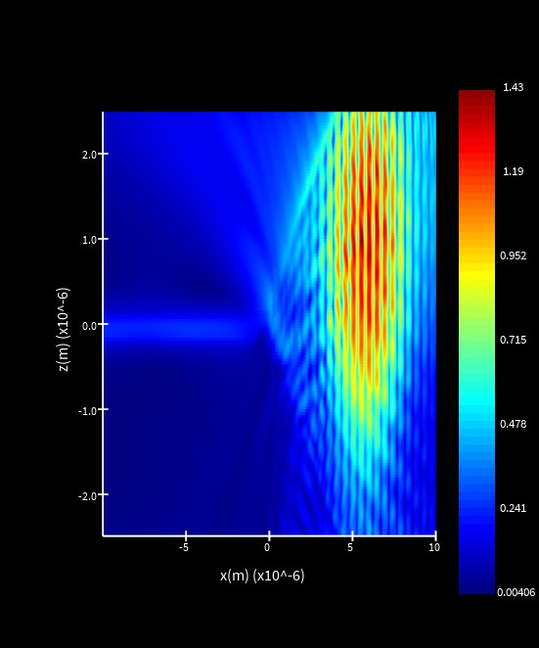
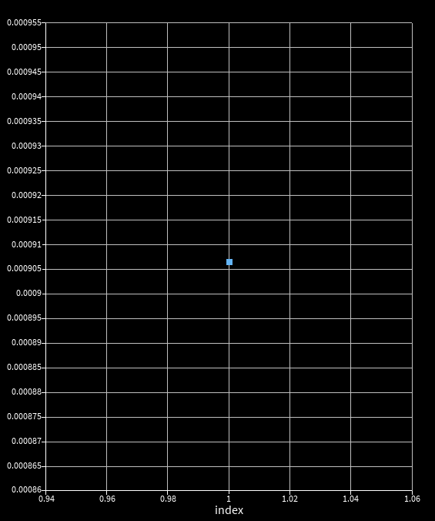
Fig. 6.6. Field-Monitor1 Fig. 6.7. Index-Monitor2

6.1.) Taper
A taper was necessary for smoother transmission from grating region to waveguide. to test the optimal taper parameters, it was simulated separately, and used a horizontal light source rather than a coupled vertical source
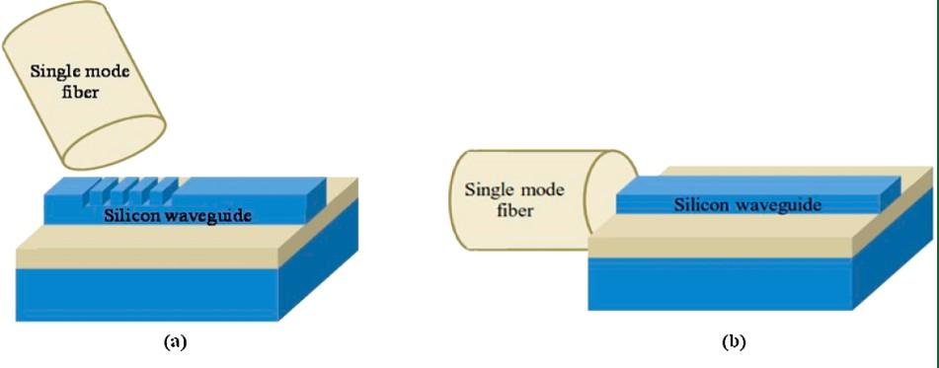
Fig. 6.8. Taper Light Source [19]

To calculate the taper angle [α], use the following equation:
α = tan⁻¹( Wg − Wwg J
2Lt

- Wg = grating width (6um)
- Wwg = waveguide width (0.35um)
- Lt = taper length
- α = taper half-angle

In general, a lower [α] leads to a smoother transition, therefore greater coupling efficiency.
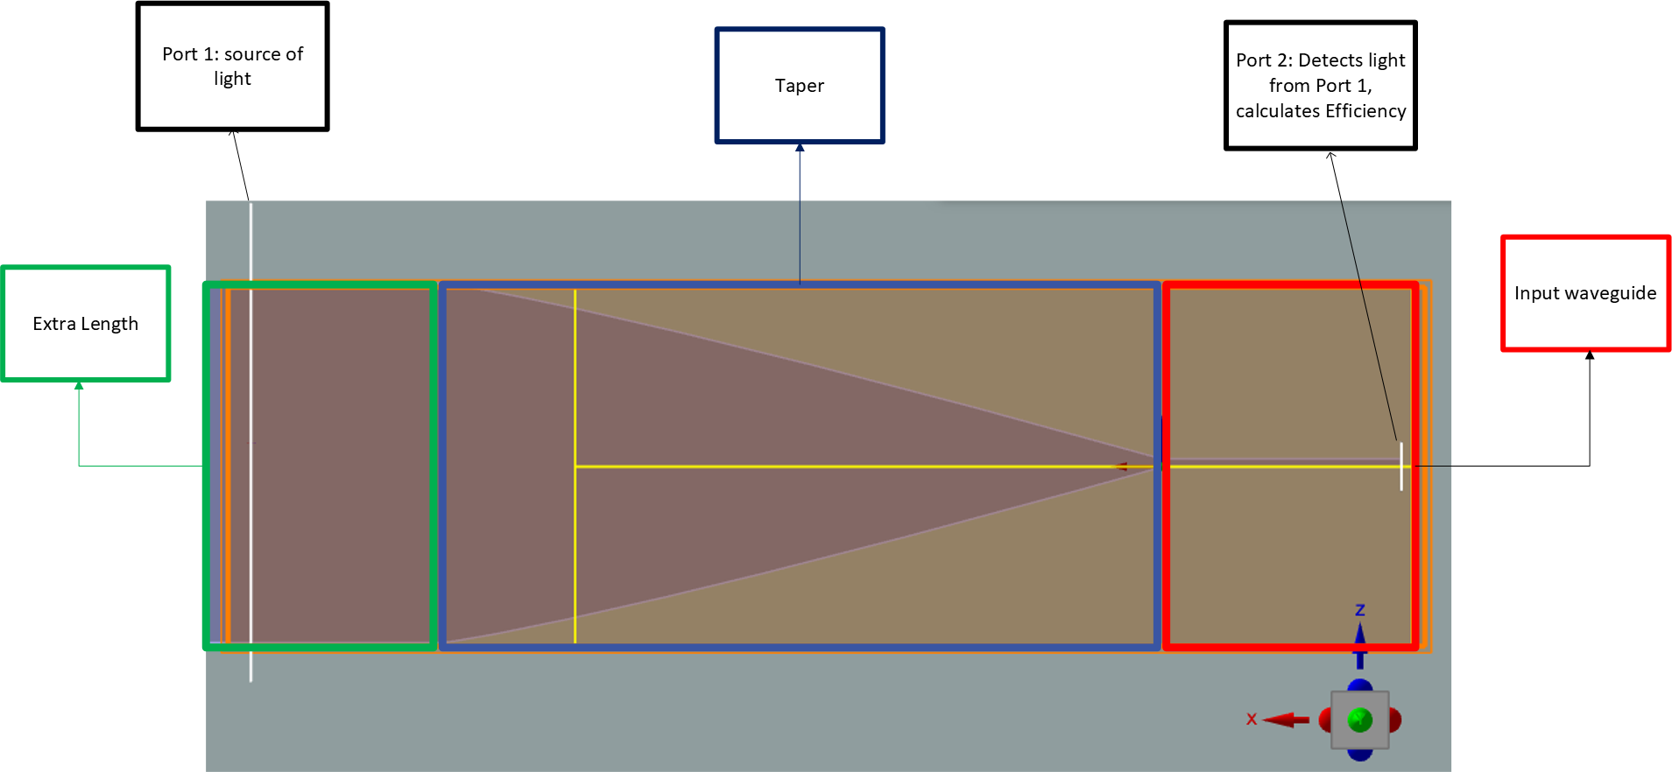
Fig. 6.9. Taper-Model (From Fig 6.8)

Taper length, Lt (µm) | Angle, α (◦) | FOM (%)
5 | 29.47 | 0.866
7.77 | 19.98 | 0.868
10.55 | 14.99 | 0.882
13.33 | 11.97 | 0.887
16.11 | 9.95 | 0.89
18.88 | 8.51 | 0.93
21.66 | 7.43 | 0.995
24.44 | 6.59 | 1.05
27.22 | 5.93 | 1.09
30 | 5.38 | 1.12

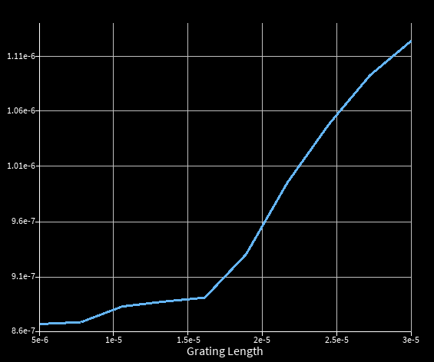
Fig. 6.10. Taper-Length Sweep
Table 5. Taper length, taper half-angle, and FOM.

The graph insists we have not find the optimal area yet due to its strong increase at the upper limit. Ranges had to be increased (Table 6)

Taper length, Lt (µm) | Angle, α (◦) | FOM
25 | 0
50 | 25
75 | 50
100 | 75 | 0.000000508203
Table 6. Taper length, taper half-angle, and FOM.

6.2.) Curved Gratings
For the curved design, the grating opening angle was estimated from simple circular geometry, ϕ = 2 sin⁻¹(Wg/(2R)). Changes in figure of merit were then used to relate geometric modifications directly to coupling performance.
ϕ = 2 sin⁻¹( Wg J
2R
- Wg = grating width (um)
- R = curvature radius of grating teeth (Degree)
- ϕ = grating opening angle (degree)
Creating the Coned-shaped grating couplers we see in literature sources mentioned in section 6 – add table of data
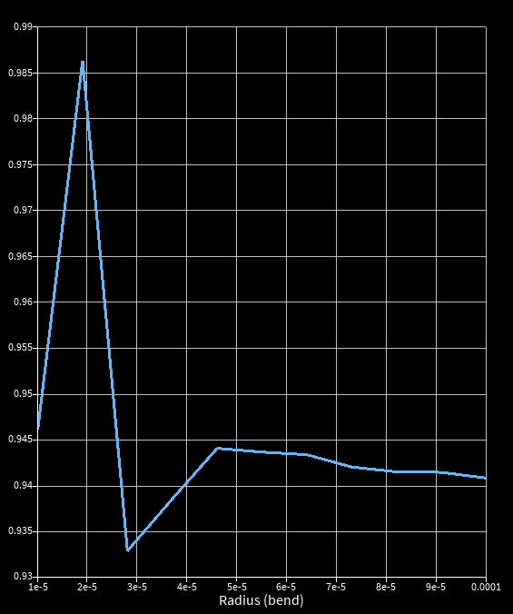
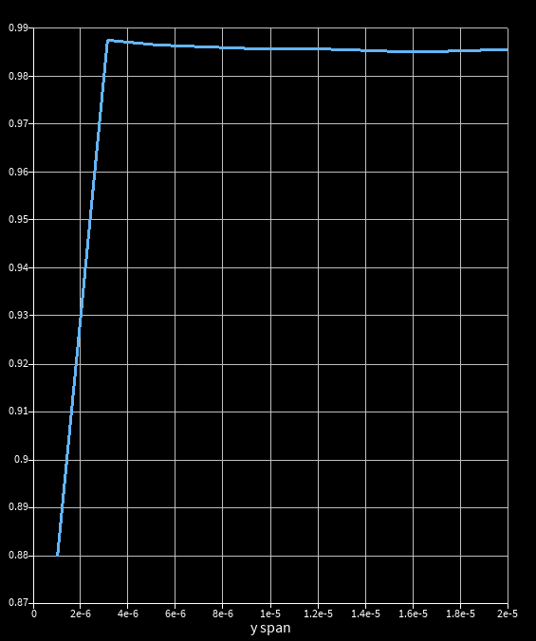
Fig. 6.11. Radius-Sweep 1 Fig. 6.12. Grating-Width 1

Grating Width Wg | Radius Sweep R | Grating opening angle ϕ | FOM (%) |  | Grating Width Wg | Radius Sweep R | Grating opening angle ϕ | FOM (%)
15 | 10 | Undefined | 94.4 |  | 1 | 25 | 2.29 | 87.8
15 | 25 | 34.92 | 95.1 |  | 3.11 | 25 | 7.13 | 98.7
15 | 50 | 17.25 | 94.4 |  | 9.44 | 25 | 21.80 | 98.5
15 | 75 | 11.48 | 94.2 |  | 13 | 25 | 30.08 | 98.5
15 | 100 | 8.60 | 94.1 |  | 20 | 25 | 47.16 | 98.6
Table 7. Radius Sweep FOM correlation Table 8. Grating width FOM correlation.

A parameter sweep was performed over bounds informed by previous data (Tables 6 and 7) to optimise both parameters, justified by their strong interdependence (Figs. 6.13–6.14).

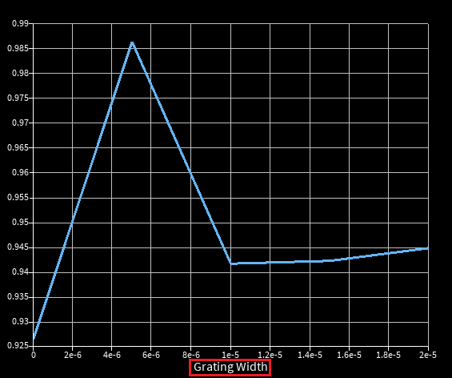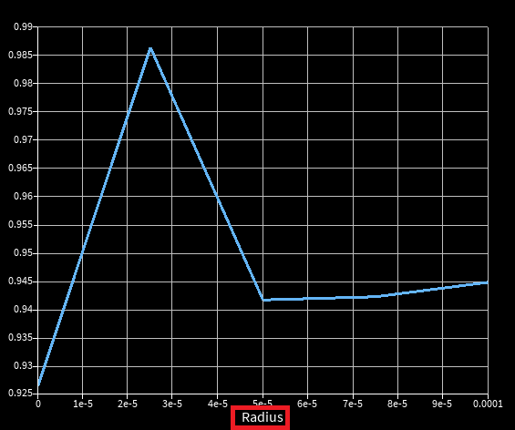
Fig. 6.13. Grating-Width 2 Fig. 6.14. Radius-Sweep 2

GDS Assembly
The final grating coupler achieved a FOM of 98.5274%, with the optimized design parameters shown in Table 9.
Table 9. Final grating coupler design parameters

Pitch (µm) | Etch Depth (µm) | Grating Length (µm) | Taper Length (µm) | Taper Half-Angle (◦) | Duty Cycle | Period Number | Radius (◦) | Taper Width (µm) | Extra Waveguide Length (µm) | Grating Width (µm)
0.6713 | 0.1 | 25 | 10 | 14.99 | 0.3992 | 38 | 25 | 15 | 10 | 5

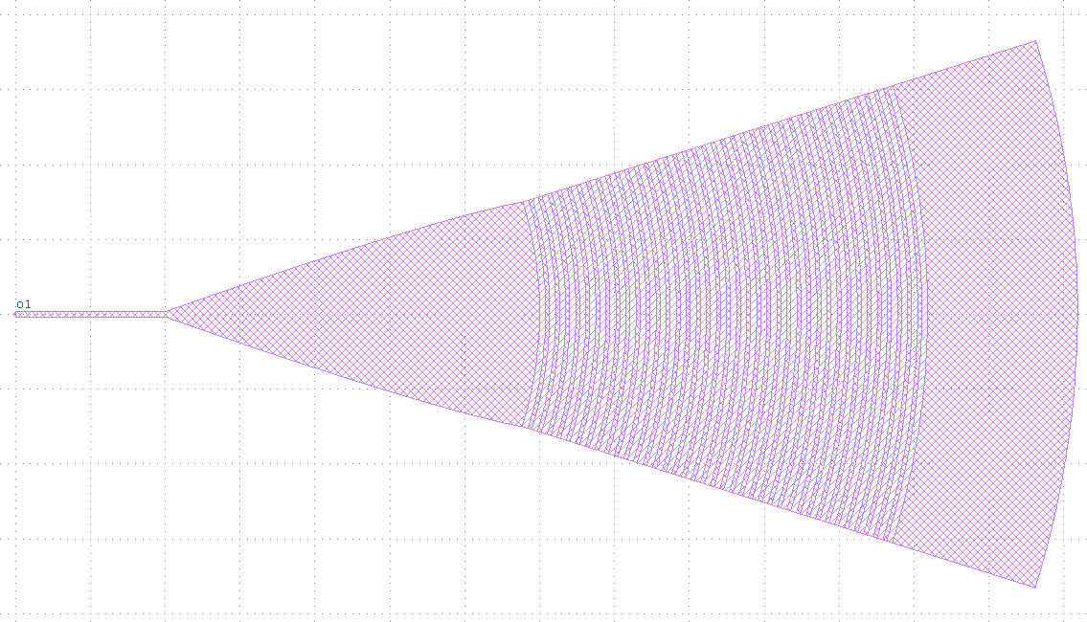

All other components were exported into GDS files
Fig. 7.1. GC GDS

Fig. 7.2. 33:66 Coupler/AMZI

Fig. 7.3. 50:50 MMI

Fig. 7.4. MZI

19

Fig. 7.5. Full-GDS

——————————————————————————————————————————————————–

Conclusion
In conclusion, the project demonstrated that a proof-of-concept SiN photonic CNOT architecture at 780 nm is feasible with strong simulated component performance.
- rating coupler achieved 98.53(%) efficiency (section 7)
- the optimised 50:50 MMI reached 96.6(%) transmission at 32.25 m core length
- and the MZI retained an estimated 93.32(%) efficiency
AMZI also achieved the required asymmetric splitting, with a ratio of 0.333 and an overall transmission of about 78.6(%).
Table 10. AMZI simulated S-bend geometries

S-bend height, y (µm) | Ratio
5.91 | 0.31692
5.8905 | 0.33067
5.9 | 0.33316
5.8895 | 0.34761
5.89 | 0.40811
5.889 | 0.42098
5.88 | 0.49421

AMZI also achieved the required asymmetric splitting, with a ratio of 0.333 and an overall transmission of about 78.6(%). The optimized 50:50 MMI reached 96.6(%) transmission at 32.25um core length, and the MZI retained an estimated 93.32(%) efficiency. The AMZI also achieved the required asymmetric splitting, with a ratio of 0.333 and an overall transmission of about 78.6(%).

ηpath = η2
GC
η_{MMI}η_{MZI}η_{AMZI} = (0.9853)²(0.966)(0.9332)(0.786) ≈ 0.6879 ≈ 68.8%

Combined, these results suggest that a representative cascaded optical path would preserve about 68.8(%) of the input power, showing that the design provides a solid basis for future refinement, fabrication, and full quantum validation.

Total word count: 1488

References References
- Ralph, T.C., Langford, N.K., Bell, T.B. and White, A.G. (2002) ‘Linear optical controlled-NOT gate in the coincidence
basis’, Physical Review A, 65(6), p. 062324.
- CORNERSTONE (2026) CORNERSTONE Photonics. Available at: https://cornerstone.sotonfab.co.uk/ (Accessed: 19 April 2026).
- Albrecht, B., Farrera, P., Fernandez-Gonzalvo, X., Cristiani, M. and de Riedmatten, H. (2014) ‘A waveguide frequency converter connecting rubidium-based quantum memories to the telecom C-band’, Nature Communications, 5(1). doi: 10.1038/ncomms4376.
- Zhang, C., Tran, M.A., Zhang, Z., Dorche, A.E., Shen, Y., Shen, B., Asawa, K., Kim, G., Kim, N., Levinson, F., Bowers, J.E. and Komljenovic, T. (2023) ‘Integrated photonics beyond communications’, Applied Physics Letters, 123(23),
p. 230501. doi: 10.1063/5.0184677.
- Blasco-Solvas, M. et al. (2024) ‘Silicon Nitride Building Blocks in the Visible Range of the Spectrum’.
- CORNERSTONE STANDARD COMPONENTS LIBRARY (On 300 nm Si3N4 Platform) (n.d.) Available at:
https://www.cornerstone.sotonfab.co.uk/wp-content/uploads/2023/07/CORNERSTONE-SiN-Standard-Components-Library-Feb-
(Accessed: 21 April 2026).
- Politi, A., Cryan, M.J., Rarity, J.G., Yu, S. and O’Brien, J.L. (2008) ‘Silica-on-Silicon Waveguide Quantum Circuits’,
Science, 320(5876), pp. 646–649. doi: 10.1126/science.1155441.
- CORNERSTONE Silicon Photonics Capabilities at the Universities of Southampton and Glasgow, UK. (n.d.) CORNERSTONE brochure. Available at: https://www.cornerstone.sotonfab.co.uk/wp-content/uploads/2023/07/ CORNERSTONE-Brochure-digital.pdf (Accessed: 19 April 2026).
- Kumar Selvaraja, S., Vermeulen, D., Schaekers, M., Sleeckx, E., Bogaerts, W., Roelkens, G., Dumon, P., Thourhout,
V. and Baets, R. (n.d.) ‘Highly efficient grating coupler between optical fiber and silicon photonic circuit’. Available at:
https://www.photonics.intec.ugent.be/download/pub_2380.pdf.
- Chen, X., Thomson, D.J., Crudginton, L., Khokhar, A.Z. and Reed, G.T. (2017) ‘Dual-etch apodised grating couplers for ef-ficient fibre-chip coupling near 1310 nm wavelength’, Optics Express, 25(15), pp. 17864–17871. doi: 10.1364/OE.25.017864.
- Hassan, S., Aamer, M., Ali, K., Khan, M.I. and Bae, J. (2020) ‘Design and analysis of polarization independent MMI based power splitter for PICs’, Microelectronics Journal, 103, 104867.
- Muratsubaki, T., Fujisawa, T., Sato, T. and Saitoh, K. (2022) ‘Proposal of mosaic-based 2 × 2 3-dB couplers for prospective on-chip communication in mid-infrared wavelengths around 2.1 µm’, Journal of the Optical Society of America B, 39(9), pp. 2522–2530.
- OZ Optics Ltd. (n.d.) OPTICAL FIBERS Features. Available at: https://www.ozoptics.com/ALLNEW_PDF/DTS0135.pdf.
- Zairmi, Y., Basdyo, D., Hairi, H.M., Aziz, M.S.A. and Abdullah, H.Y. (2022) ‘Inspection of birefringence character-istics to establish single-mode fiber quality’, Science, Technology, and Communication Journal, 2(3), pp. 91–96. doi: 10.59190/stc.v2i3.215.
- Ansys Optics (n.d.) Ports (FDTD) - Simulation Object. Available at: https://optics.ansys.com/hc/en-us/articles/ 360034382554-Ports-FDTD-Simulation-Object (Accessed: 21 April 2026).
- Henrique, L., De, M. and Da, G. (2024). 2024 - Almeida et al. [online] Available at:
https://www.researchgate.net/publication/3823302862024−Almeidaetal[Accessed21Apr.2026].
- Ansys Optics. (2017). Grating coupler. [online] Available at: https://optics.ansys.com/hc/en-us/articles/360042305334-Grating-c
[Accessed 21 Apr. 2026].
- Suhara, T. and Uemukai, M. (2007) ‘Nano Biophotonics’, in Handai Nanophotonics. Available at:
https://www.sciencedirect.com/science/article/pii/S1574064107800313 (Accessed: 21 April 2026).
- Dutta, H.S., Goyal, A.K., Srivastava, V. and Pal, S. (2016) ‘Coupling light in photonic crystal waveguides: A review’,
Photonics and Nanostructures - Fundamentals and Applications, 20, pp. 41–58. doi: 10.1016/j.photonics.2016.04.001.

